**CST-117 Programming Exercise 2**

Write a Windows Forms program that uses radio buttons, check boxes, and list boxes. Your program may do anything you wish, but should demonstrate appropriate use of each of the controls.

Here is an example:

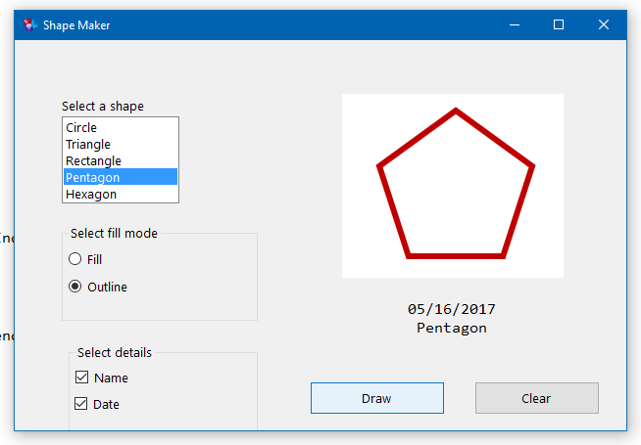

**What to submit:**

Submit all of your .cs files in your git repository with the comment “CST117_OC2.” Submit a zipped folder with all of your project files in LoudCloud.

Be prepared to demonstrate this project in class and justify your use of the controls. Be sure to review the rubric before submitting your work.